Explore the BBC archives

Find out how the BBC archives are organized at the archives’ website on http://www.bbc.co.uk/archive/index.shtml.

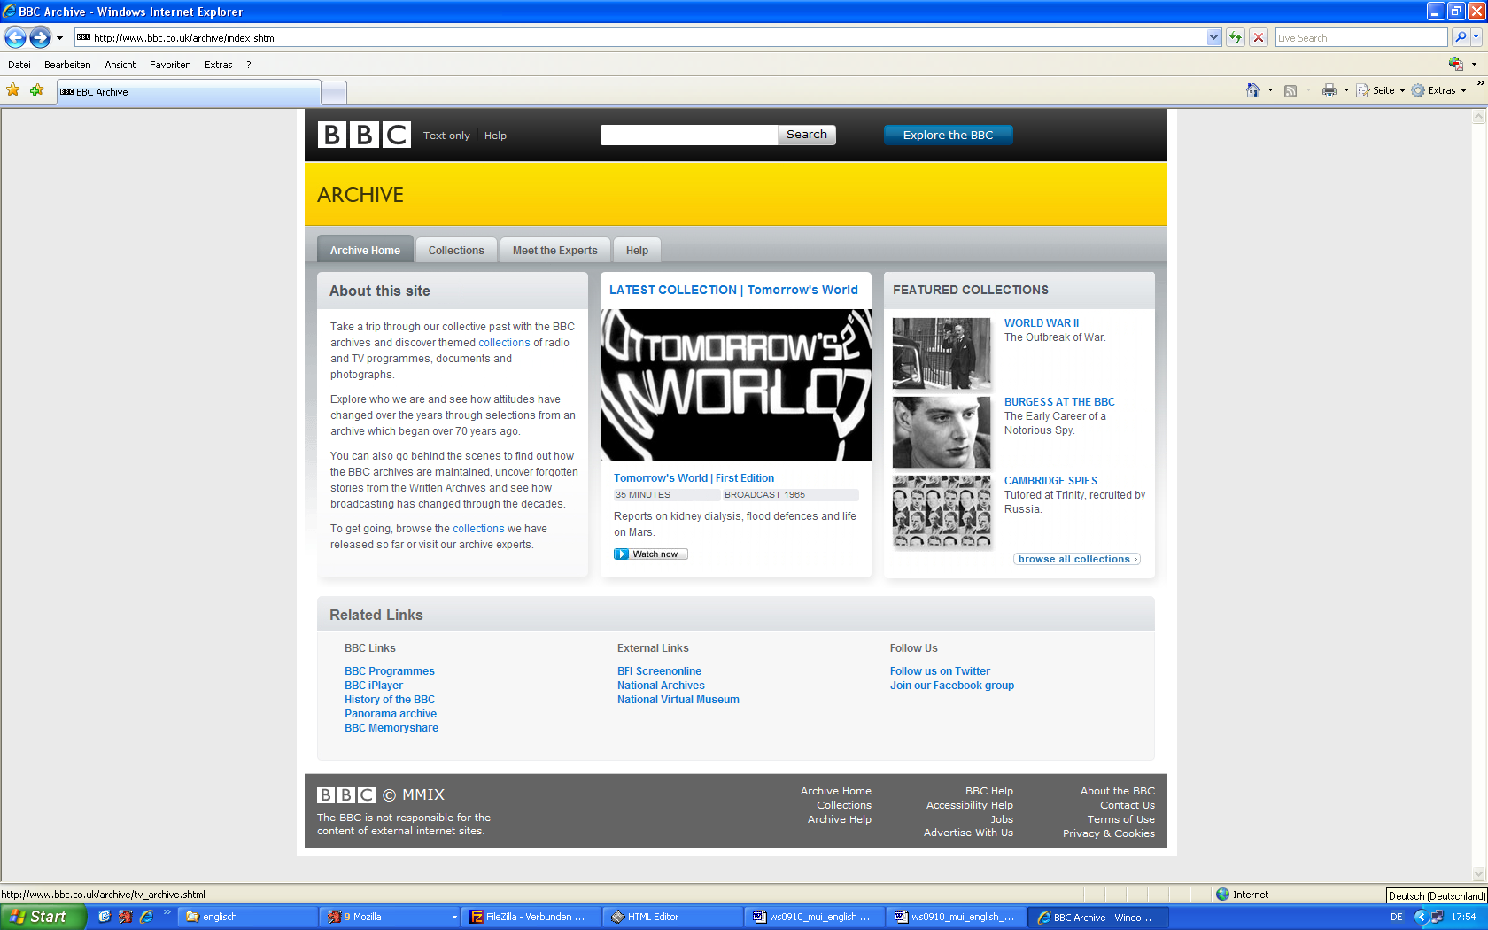

The following questions may guide you through exploring the website.

- Explore the collections and choose a collection that interests you a lot.
  - Explain a short talk for your fellow students why you are interested in the collection.
  - In our seminar “Wissensorganisation” (Knowledge Organization) we mentioned different forms of KO like abstracting, indexing, classification, and information-architecture. Can you identify some of these forms in the presented collection? Give examples and try to figure out what function they have.
- Have a look at “Meet the Experts”
  - How does the BBC decide what to keep in the archives? Look at Meet the Experts → The BBC Television Archive
  - How is the archive catalogued? Look at Meet the Experts →Cataloguing the Archive
- Now have a look at Help and try to find out a timeline of the history of the BBC.

